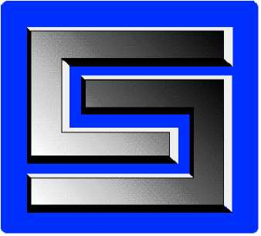

|  |  |
| --- | --- |
| Instruction:  **QP-109** | Pages: **2** |
| Printed: **01/13/2018** | Released: **12/08/2017**  Rev. Num: **0** |
| Authorized By: **Chief Engineer** | |

**TOOLING DESIGN VERIFICATION AND VALIDATION**

1. Purpose and Scope

**PURPOSE**

To define the process for verifying that tooling designs conform to all requirements and meet all customer needs.

**SCOPE**

This procedure applies to all tooling for which E.C. Styberg Engineering Co. assumes design responsibility

1. Definitions

**Verification**: Confirmation by examination and provision of objective evidence that

specified requirements have been fulfilled.

1. Process Owners

**Chief Engineer**

**Process Designees: Project Engineer**

**4. Procedures**

**4.1 Project Engineer**

**Document Design Verification**

The Project Engineer/Q.A. Tech prepares a written log of design verification performed through analysis, laboratory tests and calculation, including prototyping and simulation.

**Monitors Concerns and Corrective Action**

The Project Engineer initiates written corrective action as required in order to resolve concerns resulting from the verification and validation process.

**Reviews Design**

If needed, the Project Engineer chairs one or more Design Review meetings with members of the Engineering Department, which may also include the V.P. of Manufacturing.

**4.2 Chief Engineer**

**Releases Design to Customer**

If required, upon completion of verification, validation processes (refer to 5.2 'reference documents') and corrective action for all concerns, the Chief Engineer approves design for final customer release. (With customer approval, design release may be initiated before completion of validation if required to meet customer timing.)

**5 References**

**5.1 Related Procedure**

Advanced Product Quality Planning QP-106

Production Design: QP-108

Design Changes QP-110

**5.2 Reference Documents**

**None**

**6. Records**

**None**

**7. Policy References**

**None**

**8. Revisions of QP-109**